1.

C Program:

1 #include <stdio.h>
2 #include <stdlib.h>
3 #include <math.h>
4 float mean(int *a, int n){
5 int sum=0,i;
6 for (i=0;i<n;i++){
7 sum+=*(a+i);
8 }
9 return sum/n;
10 }
11 void inssort(int *a, int n){
12 int i,j,tmp;
13 for(i=1;i<n;i++){
14 j=i-1;
15 tmp=*(a+i);
16 while(*(a+j)>tmp && j>=0){
17 *(a+j+1)=*(a+j);
18 j--;
19 }
20 *(a+j+1)=tmp;
21 }
22 for(i=0;i<n;i++){
23 printf("%d ",*(a+i));
24 }
25 }
26
27 int median(int *a, int n){
28 inssort(a,n);
29 int mid = (n-1)/2;
30 return *(a+mid);
31
32 }
33 void delete(int *a,int *n,int k){
34 int i;
35
36 for(i=k;i<*n;i++){
37 a[i]=a[i+1];
38 }
39 *n-=1;
40 }
41
42 void makeUnique(int *a,int *n){
43 int i,j;
44 for (i=0;i<*n;i++){
45 for (j=i+1;j<*n;j++){
46 if(*(a+i)==*(a+j)){
47 i--;
48 delete(a,n,j);
49 }
50 }
51 }
52
53 }
54
55 int mode(int *a, int *n){
56 int counter,max=0,index=0,i,j;
57 for (i=0;i<*n;i++){
58 counter = 0;
59 for (j=0;j<*n;j++){
60 if(*(a+i)==*(a+j)){
61 counter ++;
62 }
63 }
64 if (counter>max){
65 max = counter ;
66 index = i;
67 }
68 }
69 return *(a+index);
70 }
71
72 int range(int *a , int n){
73 int max=0,min=0;
74 int i;
75
76 for(i=1;i<n;i++){
77 if(*(a+max)<*(a+i)){
78 max=i;
79 }
80 if(*(a+min)>*(a+i)){
81 min=i;
82 }
83 }
84 return *(a+max)-*(a+min);
85 }
86
87 float variance(int *a, int n){
88 float term1=0;
89 int i;
90 for (i=0;i<n;i++){
91 term1+=*(a+i) * *(a+i);
92
93 }
94 term1/=n;
95 return term1 - (mean(a,n)*mean(a,n));
96
97 }
98
99 float stdDev(int *a, int n){
100 return sqrt(variance(a,n));
101 }
102
103
104
105
106
107
108
109
110
111
112 void main(){
113 int n=0,i;
114 printf("Enter Number of Elements\n");
115 int *a = (int *)malloc(sizeof(int)*n);
116 int *u = (int *)malloc(sizeof(int)*n);
117 scanf("%d",&n);
118 printf("Enter the Elements\n");
119 for(i=0;i<n;i++){
120 scanf("%d",a+i);
121 u[i]=a[i];
122 }
123 int entry=1;
124 makeUnique(a,&n);
125 printf("After Removing Repeating Elements:\n");
126 for (i=0;i<n;i++){
127 printf ("%d ",a[i]);
128 }
129 while (entry!=0){
130 printf("\n1.Mean, 2.Median, 3.Mode, 4.Variance, 5. Standard Deviation, 6,Range 0.Exit\n");
131 scanf("%d",&entry);
132 switch (entry){
133 case 1:
134 printf("Mean of the Distribution is: %f\n",mean(a,n) );
135 break;
136 case 2:
137 printf("Median of the Distribution is: %d\n",median(a,n) );
138 break;
139 case 3:
140 printf("Mode of the Distribution is: %d\n",mode(u,&n) );
141 break;
142 case 4:
143 printf("Variance of the Distribution is: %f\n",variance(a,n) );
144 break;
145 case 5:
146 printf("Standard Deviation of the Distribution is: %f\n",stdDev(a,n) );
147 break;
148 case 6:
149 printf("Range of the distribution is: %d\n",range(a,n) );
150 break;
151 }
152 }
153 free(a);
free(u);
154 }

Input/Output:

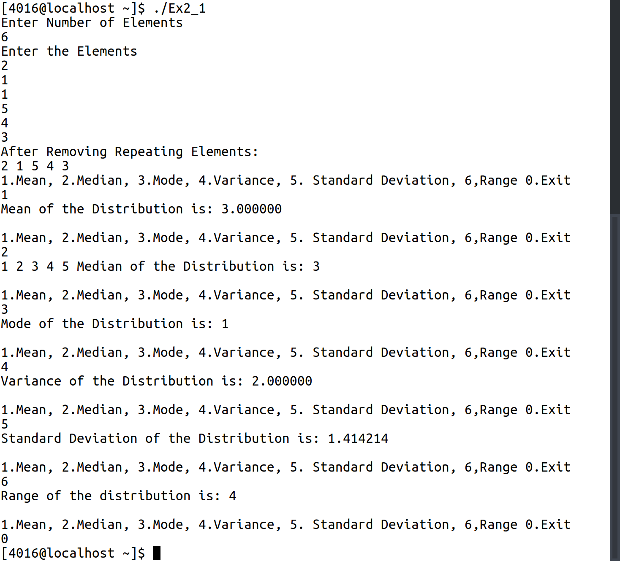

2.

C Program:
1 #include <stdio.h>
2 #include <string.h>
3
4 void insert(char d[10][50],int *n, char s[50]){
5 int j=*n-1;
6 while (strcmp(d[j],s)>0 && j>=0){
7 strcpy(d[j+1],d[j]);
8 j--;
9 }
10 strcpy(d[j+1],s);
11 *n+=1;
12
13 }
14
15 int binsearch(char d[10][50],int *n, char s[50]){
16 int ul=*n-1;
17 int ll=0;
18 int retVal=-1;
19 while(ul>=ll){
20 int mid = (ul+ll)/2;
21 if(strcmp(d[mid],s)==0){
22 retVal= mid;
23 //return retVal;
24 break;
25
26 }
27 else if (strcmp(d[mid],s)<0){
28 ll=mid+1;
29
30 }
31 else if(strcmp(d[mid],s)>0){
32 ul=mid-1;
33 }
34
35 }
36 return retVal;
37
38 }
39
40 void delete(char d[10][50],int *n, char s[50]){
41 int i;
42 int k=binsearch(d,n,s);
43 if(k>=0){
44 for(i=k;i<*n-1;i++){
45 strcpy(d[i],d[i+1]);
46 }
47 *n-=1;
48 printf("Deleted\n");
49 }
50
51 else{
52 printf("Not Found\n");
53 }
54 }
55
56 void main(){
57 char a[10][50]={"apple","ball","dog"};
58 int i;
59 int length=3;
60
61 int entry=1;
62 char op[50];
63 while(entry!=0){
64 printf("1.Insert, 2.Delete, 3.Search, 4.Display 0.Exit\n");
65 scanf("%d%*c",&entry);
66 switch(entry){
67 case 1:
68 printf("Enter word to be inserted\n");
69 scanf("%s",op);
70 insert(a,&length,op);
71 break;
72 case 2:
73 printf("Enter word to be deleted\n");
74 scanf("%s",op);
75 delete(a,&length,op);
76 break;
77 case 3:
78 printf("Enter word to be searched\n");
79 scanf("%s",op);
80 printf("Found at Index : %d\n",binsearch(a,&length,op));
81 break;
82 case 4:
83 for(i=0;i<length;i++){
84 printf("%s\n",a[i]);
85 }
86 break;
87 }
88 }
89 }

Input/Output:

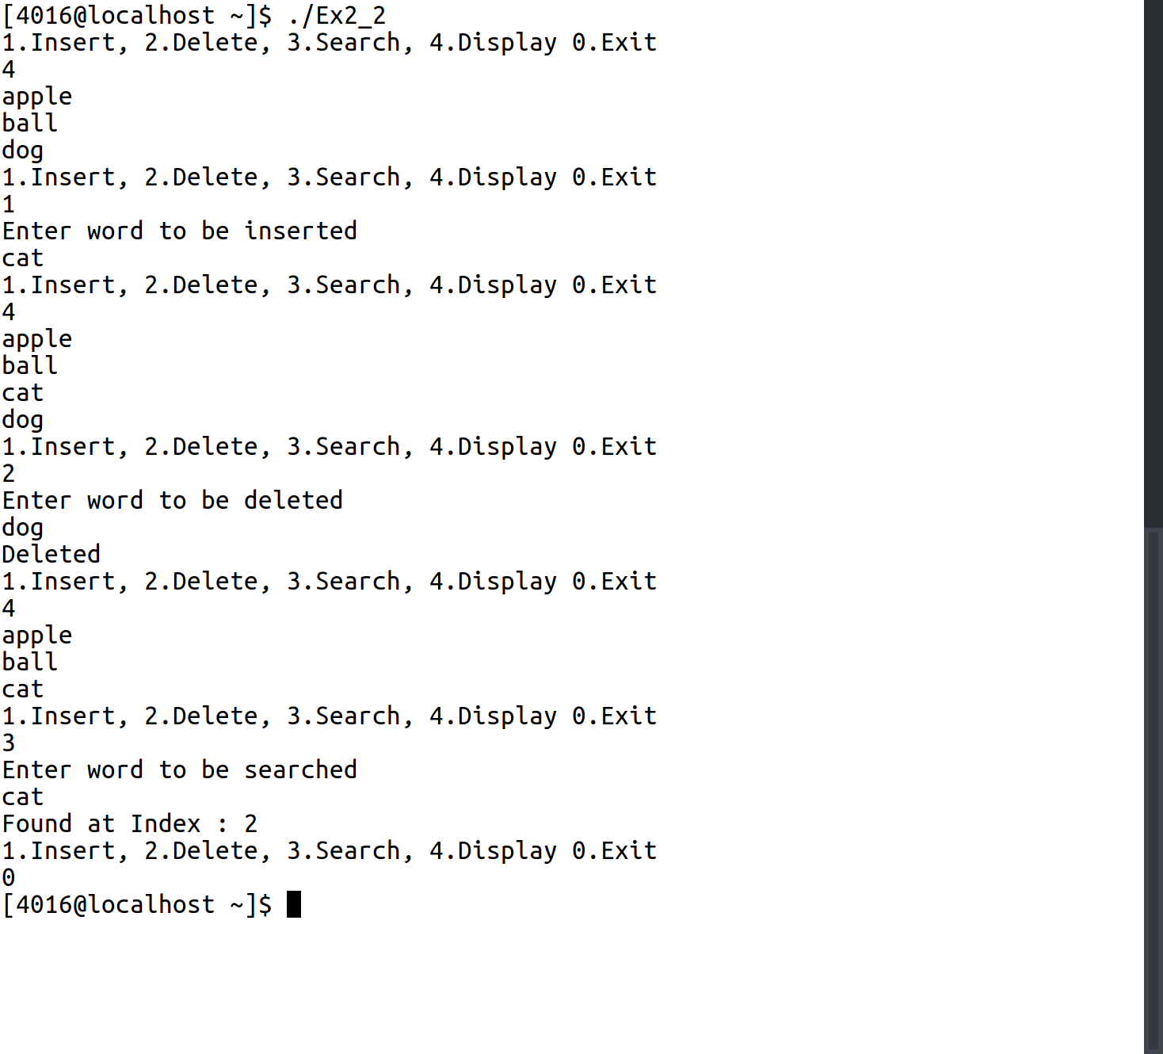

3.

C Program:

1 #include <stdio.h>
2 #include <string.h>
3 #include <stdlib.h>
4
5 void caesarcipher(char *str){
6 int i=0,b;
7 while(*(str+i)!='\0'){
8 if (*(str+i)==' ' || *(str+i)=='\n'){
9 i++;
10 continue;
11 }
12 b=*(str+i);
13 b+=3;
14 if (b>122){
15 b=97+(b-122-1);
16 }
17
18 *(str+i)= b;
19 i++;
20 }
21 }
22
23
24 void decipher(char *str){
25 int i=0,b;
26 while(*(str+i)!='\0'){
27 if (*(str+i)==' ' || *(str+i)=='\n'){
28 i++;
29 continue;
30 }
31 b=*(str+i);
32 b-=3;
33 if (b<97){
34 b=122-(97-b-1);
35 }
36
37 *(str+i)= b;
38 i++;
39 }
40 }
41
42 void main(){
43 int i=1;
44 while (i){
45 printf ("1.Cipher, 2. Decipher: ");
46 scanf("%d%*c",&i);
47 char *s = (char *)malloc(sizeof(char)*500);
48 printf("Enter String\n");
49 fgets(s,499,stdin);
50 switch(i){
51 case 1:
52 caesarcipher(s);
53 puts(s);
54 break;
55 case 2:
56 decipher(s);
57 puts(s);
58 break;
59 }
60 free(s);
61 }
62 }

Input/Output:

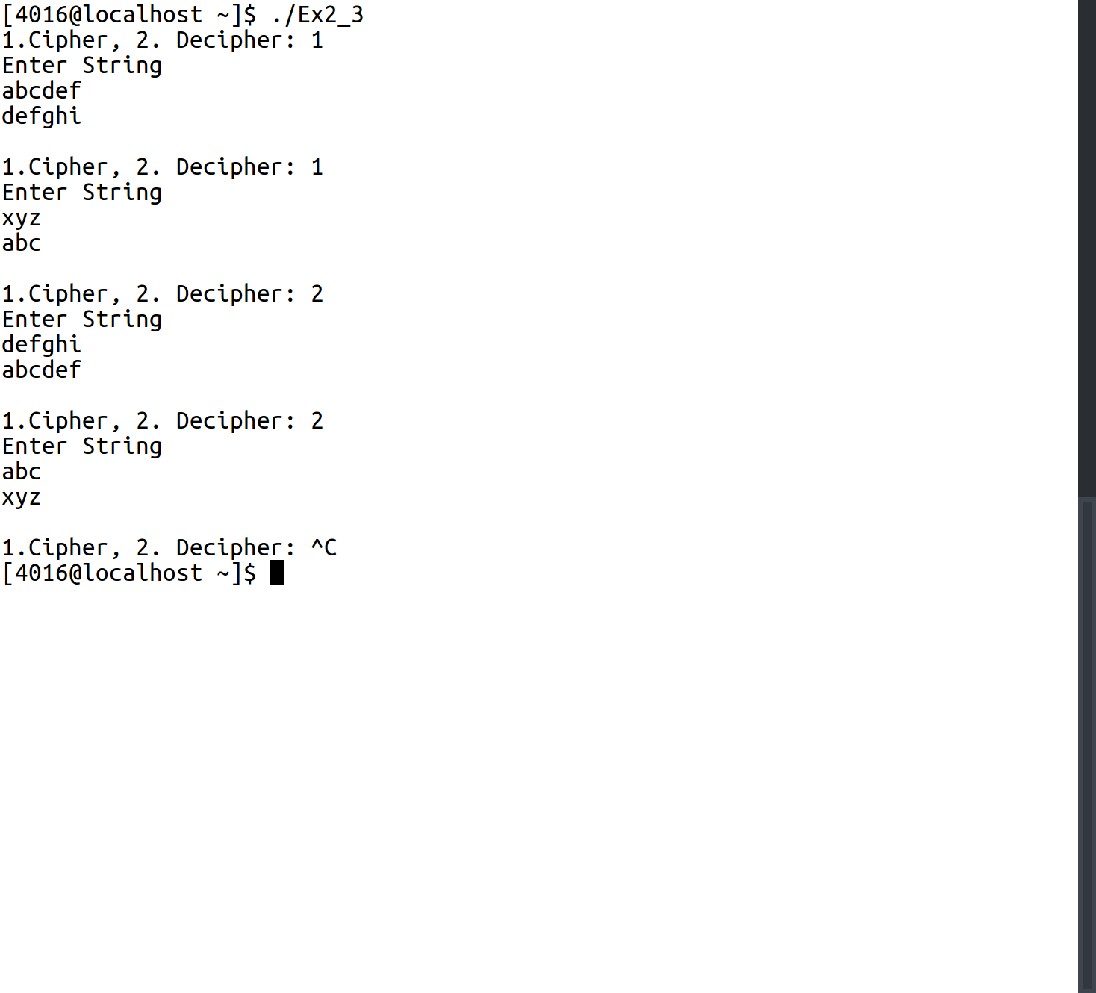

4.

C Program:

1 #include <stdio.h>
2 #define N 2
3
4
5
6 int find(int year[N], int n){
7 int i;
8 for (i=0;i<N;i++){
9 if(n== year[i]) return i;
10 }
11 }
12
13
14
15 void fn1(char city[N][50], int year[N], int lit[N][N],int m, int n){
16 n=find(year,n);
17 printf("Literacy Rate of %s in the year %d is : %d", city[m], year[n], lit[m][n]);
18
19 }
20
21 void fn2(char city[N][50], int year[N], int lit[N][N],int n){
22 n=find(year,n);
23 int max=0;
24 int i;
25 for (i=0;i<N;i++){
26 if ( lit[i][n]> lit[max][n]){
27 max=i;
28 }
29 }
30
31 printf("In the Year %d, %s had the highest literacy rate of %d out of all other cities", year[n], city[max], lit[max][n]);
32
33 }
34
35 void fn3(char city[N][50], int year[N], int lit[N][N],int n){
36 n=find(year,n);
37 int min=0;
38 int i;
39 for (i=0;i<N;i++){
40 if ( lit[i][n]< lit[min][n]){
41 min=i;
42 }
43 }
44
45 printf("In the Year %d, %s had the lowest literacy rate of %d out of all other cities", year[n], city[min], lit[min][n]);
46
47 }
48 void fn4(char city[N][50], int year[N], int lit[N][N], int m){
49
50 int i;
51 float sum=0;
52 for (i=0;i<N;i++){
53 sum+= lit[m][i];
54 }
55 sum/=N;
56 printf("The average literacy rate in %s over the last 10 years is: %.2f", city[m],sum);
57 }
58
59 void fn5(char city[N][50], int year[N], int lit[N][N]){
60 int i,j;
61 for (i=0;i<N;i++){
62 printf("\t%5d", year[i]);
63 }
64 printf("\n");
65 for (i=0;i<N;i++){
66 printf("%s", city[i]);
67 for(j=0;j<N;j++){
68 printf("\t%5d", lit[i][j]);
69 }
70 printf("\n");
71 }
72 }
73
74
75
76
77
78
79
80 void main(){
81 char city[N][50];
82 int year[N];
83 int lit[N][N];
84 int i,j,entry=1;
85 int m,n;
86 for (i=0;i<N;i++){
87 printf("Enter City %d: ",i+1);
88 scanf("%s",&city[i]);
89 }
90 for (i=0;i<N;i++){
91 printf("Enter Year %d: ",i+1);
92 scanf("%d",&year[i]);
93 }
94 for (i=0;i<N;i++){
95 for (j=0;j<N;j++){
96 printf("Enter Literacy Rate of %s in the year %d: ",city[i],year[j]);
97 scanf("%d",&lit[i][j]);
98 }
99 }
100 while(entry!=0){
101 printf("\n1.Find the literacy percentage in m city in n year\n2. Find which city has the highest number of literate people in any year\n3. Find which city has the lowest number of literate people in any year\n4. Find the average of literate people in any city for N years\n5. Display the entire data\n");
102 scanf("%d",&entry);
103 switch (entry){
104 case 1:
105 printf("Enter City Number and Year: ");
106 scanf("%d %d",&m,&n);
107 fn1(city, year, lit,m-1,n);
108 break;
109 case 2:
110 printf("Enter Year: ");
111 scanf("%d",&n);
112 fn2(city, year, lit,n);
113 break;
114 case 3:
115 printf("Enter Year: ");
116 scanf("%d",&n);
117 fn3(city, year, lit,n);
118 break;
119 case 4:
120 printf("Enter City Number: ");
121 scanf("%d",&m);
122 fn4(city, year, lit,m-1);
123 break;
124 case 5:
125 fn5(city, year, lit);
126 break;
127
128 }
129 }
130 }

Input/Output:
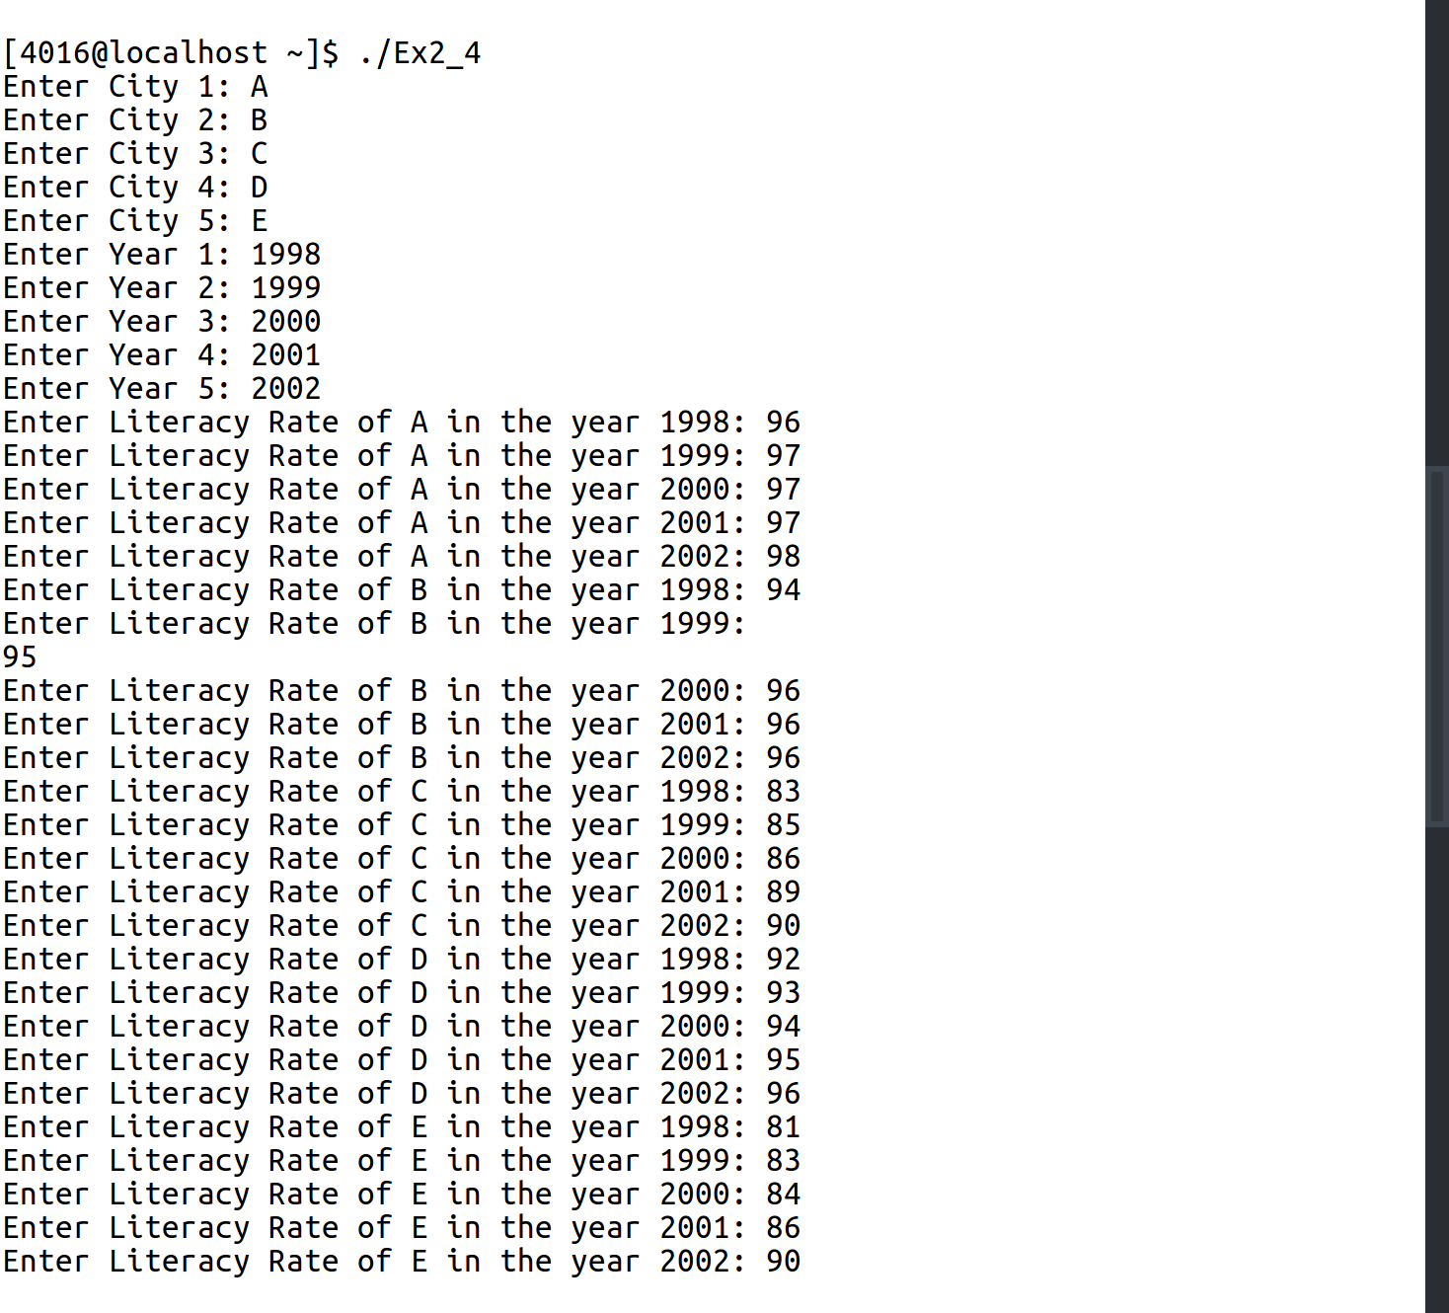
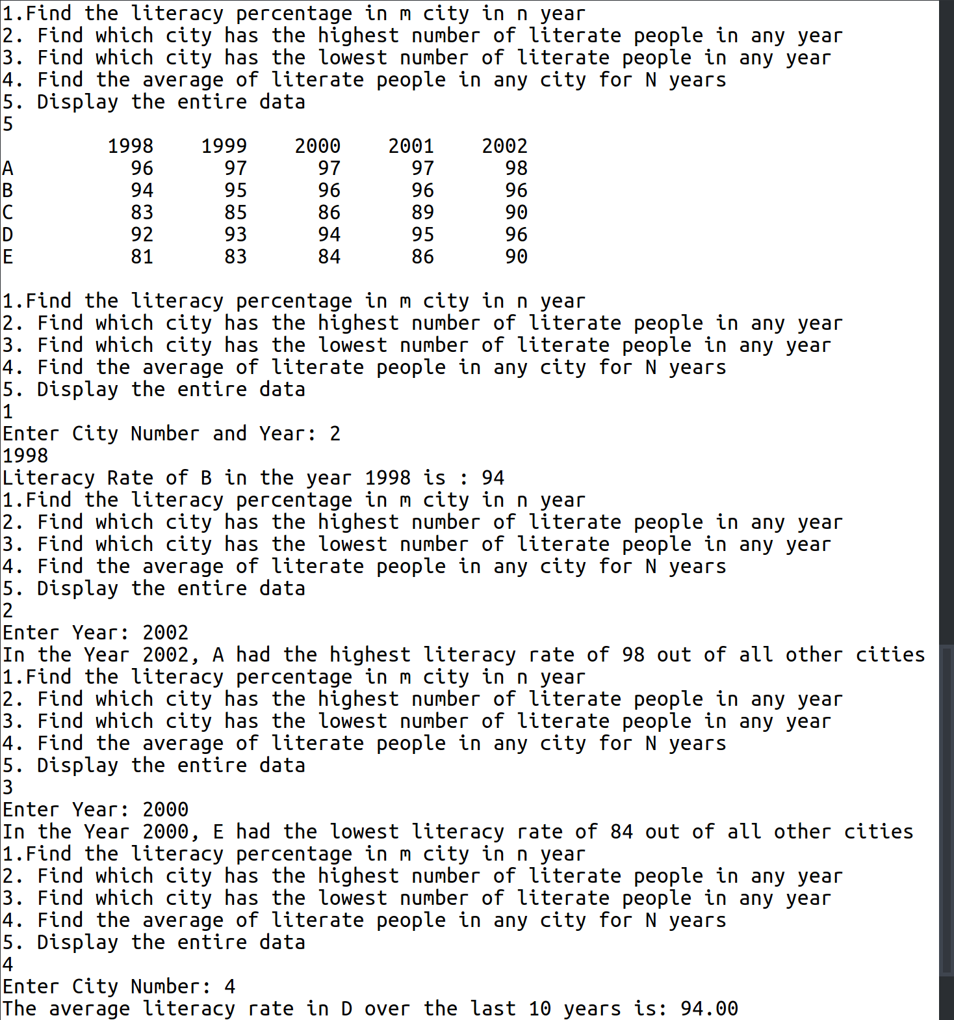

5.

C Program:
1 #include <stdio.h>
2
3 int sum(int n){
4 int sum=0;
5 while (n!=0){
6 sum+=n%10;
7 n/=10;
8 }
9 return sum;
10 }
11
12 int sumrec(int n){
13 if (n==0){
14 return 0;
15 }
16 else{
17 return ((n%10) + sumrec(n/10));
18 }
19 }
20
21
22 void main(){
23 int n;
24 printf("Enter Number\n");
25 scanf("%5d",&n);
26 printf("Sum of Digits Calculated without Recursion: %d \nSum of Digits Calculated with Recursion: %d\n",sum(n),sumrec(n));
27 }

Input/Output:

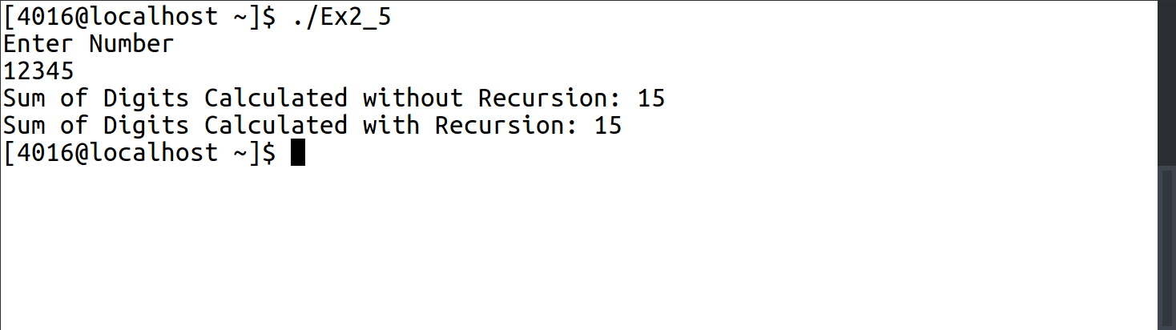

6.

C Program:

1 #include <stdio.h>
2
3 int fibo(int n, int *a){
4 *a+=1;
5 if (n<=1){
6 return n;
7 }
8 else{
9
10 return fibo(n-2,a)+fibo(n-1,a);
11 }
12 }
13
14 void main(){
15 int n,i,a;
16 int count=0;
17 int garbage;
18 printf("Enter N\n");
19 scanf("%d",&n);
20 for(i=0;fibo(i,&garbage)<n;i++){
21 printf("%d ",fibo(i,&count));
22 }
23 printf("\nThe function was called %d times\n",count);
24 }

Input/Output:

